'Programmer: Samantha Naini
'Date: 3/12/2012
'Exercise: 4-3-27 pg. 141
'Program purpose: Write a program that requests an exam score and assigns a letter grade with a set scale.

Option Strict On
Option Explicit On

Public Class frmGrades

Private Sub btnGetGrade_Click(ByVal sender As System.Object, ByVal e As System.EventArgs) Handles btnGetGrade.Click

Dim score As Integer, letterGrade As String
score = CInt(InputBox("What is the score?"))

Select Case score

Case 90 To 100
letterGrade = "A"
Case 80 To 89
letterGrade = "B"
Case 70 To 79
letterGrade = "C"
Case 60 To 69
letterGrade = "D"
Case 0 To 59
letterGrade = "F"
Case Else
letterGrade = "Invalid"
End Select
txtOutput.Text = "The letter grade is " & letterGrade & "."
End Sub

Private Sub btnClear_Click(ByVal sender As System.Object, ByVal e As System.EventArgs) Handles btnClear.Click
txtOutput.Clear()
End Sub

Private Sub btnEnd_Click(ByVal sender As System.Object, ByVal e As System.EventArgs) Handles btnEnd.Click
Me.Close()
End Sub
End Class
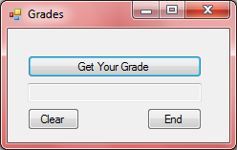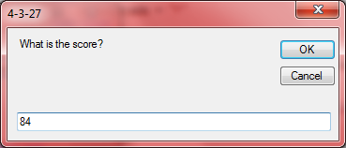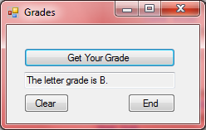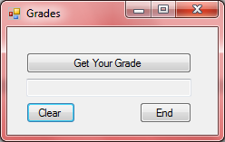←clear button
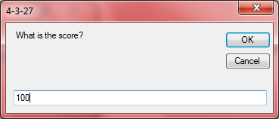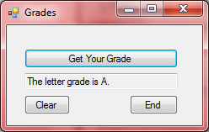
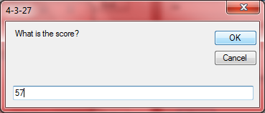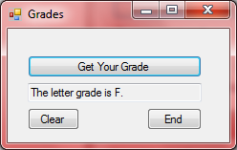
'Programmer: Samantha Naini
'Date: 3/12/2012
'Exercise: 4-3-28 pg. 141
'Program Purpose: Write a program that displays state facts.

Option Strict On
Option Explicit On

Public Class frmStateFacts

Private Sub btnDisplay_Click(ByVal sender As System.Object, ByVal e As System.EventArgs) Handles btnDisplay.Click

Dim Category, State, Answer As String

State = txtState.Text.ToUpper()
Category = txtCat.Text.ToUpper.Substring(0, 1)

Select Case State & Category

Case "CALIFORNIAF"
Answer = "The California state flower is the Golden Poppy."

Case "CALIFORNIAN"
Answer = "California's nickname is the Golden State."

Case "CALIFORNIAM"
Answer = "California's motto is 'Eureka'."

Case "INDIANAF"
Answer = "Indiana's flower is the Peony."

Case "INDIANAN"
Answer = "Indiana's nickname is the Hoosier State."

Case "INDIANAM"
Answer = "Indiana's motto is 'the crossroads of America'."

Case "MISSISSIPPIF"
Answer = "Mississippi's flower is the Magnolia."

Case "MISSISSIPPIN"
Answer = "Mississippi's nickname is 'the Magnolia State'."

Case "MISSISSIPPIM"
Answer = "Mississippi's motto is 'by valor and arms'."

Case "NEW YORKF"
Answer = "New York's flower is the Rose."

Case "NEW YORKN"
Answer = "New York's nickname is the Empire State."

Case "NEW YORKM"
Answer = "New York's motto is 'Ever upward'."
Case Else
Answer = "invalid"

End Select

txtFact.Text = Answer

End Sub

Private Sub btnClear_Click(ByVal sender As System.Object, ByVal e As System.EventArgs) Handles btnClear.Click
txtFact.Clear()
txtState.Clear()
txtState.Focus()
End Sub

Private Sub btnEnd_Click(ByVal sender As System.Object, ByVal e As System.EventArgs) Handles btnEnd.Click
Me.Close()
End Sub

End Class

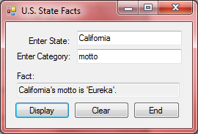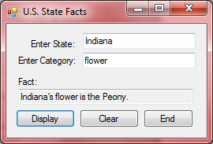
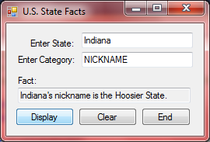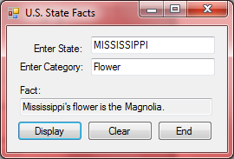

'Programmer: Samantha Naini
'Date: 3/12/2012
'Exercise 4-3-32 pg. 142
'Program purpose: Write a program that allows to to pick a number from 1-3 and receive either an insult or a humorous quote.

Option Strict On
Option Explicit On

Public Class frmExercise32

Private Sub btnHumor_Click(ByVal sender As System.Object, ByVal e As System.EventArgs) Handles btnHumor.Click
Dim num As Integer

num = CInt(txtNumber.Text)

Select Case num
Case 1 To 1
txtSentence.Text = "'I cook with wine. Sometimes, I even add it to the food.' - W. C. Fields"
Case 2 To 2
txtSentence.Text = "'He taught me housekeeping; when I divorce I keep the house.' - Zsa Zsa Gabor"
Case 3 To 3
txtSentence.Text = "'Parrots make great pets. They have more personality than goldfish.' - Chevy Chase"
Case Else
txtSentence.Clear()
txtNumber.Clear()
txtNumber.Focus()
End Select

End Sub

Private Sub btnInsult_Click(ByVal sender As System.Object, ByVal e As System.EventArgs) Handles btnInsult.Click
Dim num As Integer

num = CInt(txtNumber.Text)

Select Case num
Case 1 To 1
txtSentence.Text = "Is your name Laryngitis? You're a pain in the neck!"
Case 2 To 2
txtSentence.Text = "I bet your brain feels as good as new, seeing that you've never used it."
Case 3 To 3
txtSentence.Text = "You have an inferiority complex -- and it's fully justified."
Case Else
txtSentence.Clear()
txtNumber.Clear()
txtNumber.Focus()
End Select

End Sub

End Class

Pressing the Humor button:
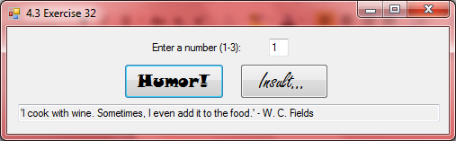
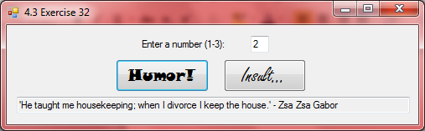
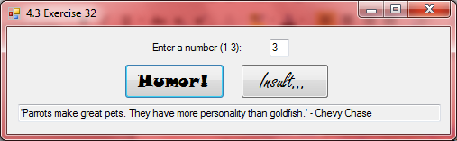
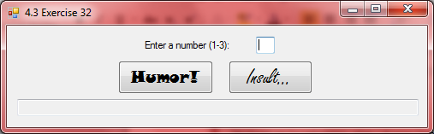←if I enter a value other than 3, the program resets
Pressing the insult button:
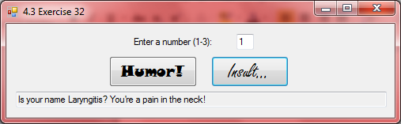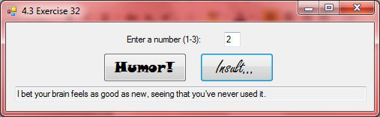

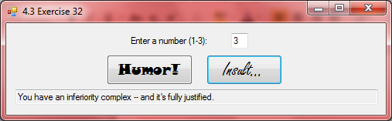
←if I enter a value other than 3 again, the program resets

